Uganda Joins Four Key WIPO Copyright Treaties
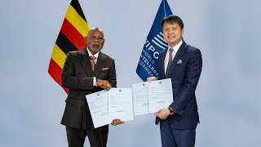
Hon. Abubakhar Jeje Odongo, Uganda's Minister of Foreign Affairs delivers accession/ratification instruments to the WIPO Director General Daren Tang.

On January 28, 2022, Hon. Abubakhar Jeje Odongo, Uganda's Minister of Foreign Affairs, deposited the instruments of ratification and accession with the Director General of the World Intellectual Property Organisation (WIPO) in respect to four copyright Treaties; The Berne Convention, the WIPO Copyright Treaty, the WIPO Performances and Phonograms Treaty, and the Beijing Treaty on Audiovisual Performances.
The WIPO Director General Daren Tang welcomed Uganda's new membership in four key WIPO Copyright Treaties, which are designed to fit together seamlessly, to ensure all relevant creative sectors benefit from an appropriate level of rights recognition – from recorded music, movies, television shows, written works, to audiovisual performances, computer programs and much more.
You can watch the Accession/Ratification ceremony on YouTube: https://www.youtube.com/watch?v=ObfN3hRtDKw&t=2s

